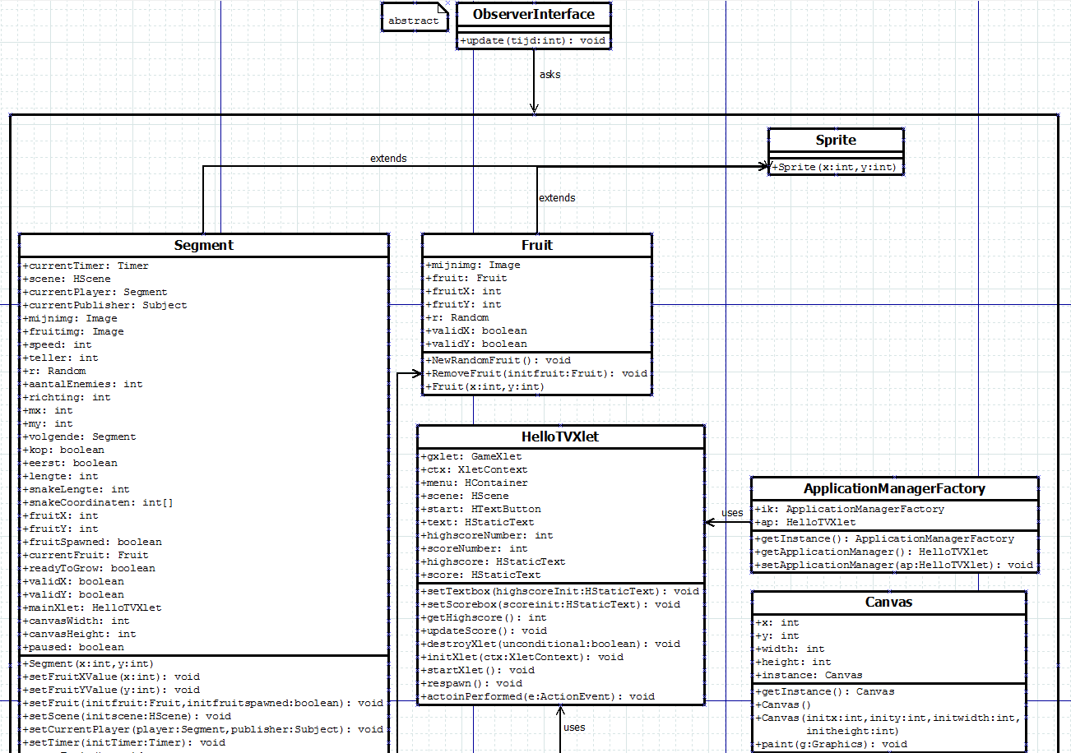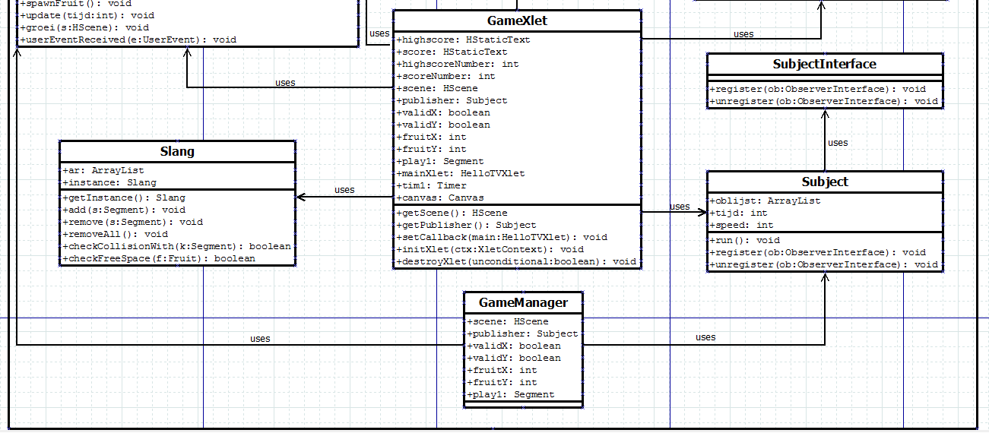

Jarno Hermans, Degryse Daphne, Brent Belmans Design Patter : Snake Spel